Setting up RapidAPI.

1. Go to this [link.](https://rapidapi.com/auth/sign-up?referral=/hub)

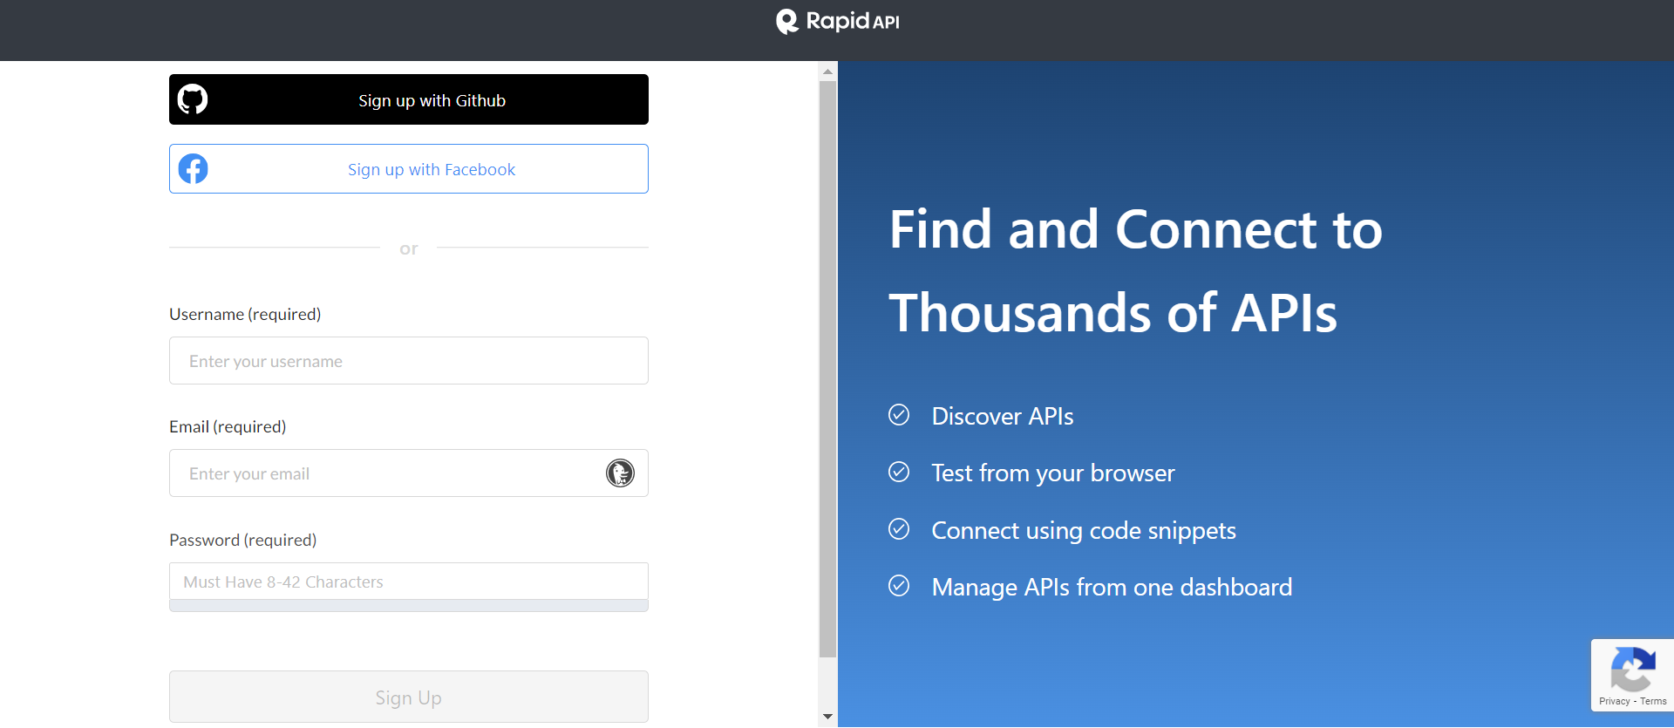

Fill up the details or you can signup with GitHub or Facebook.

After filling up details click on Sign Up.

1. After verification you need to fill some details.

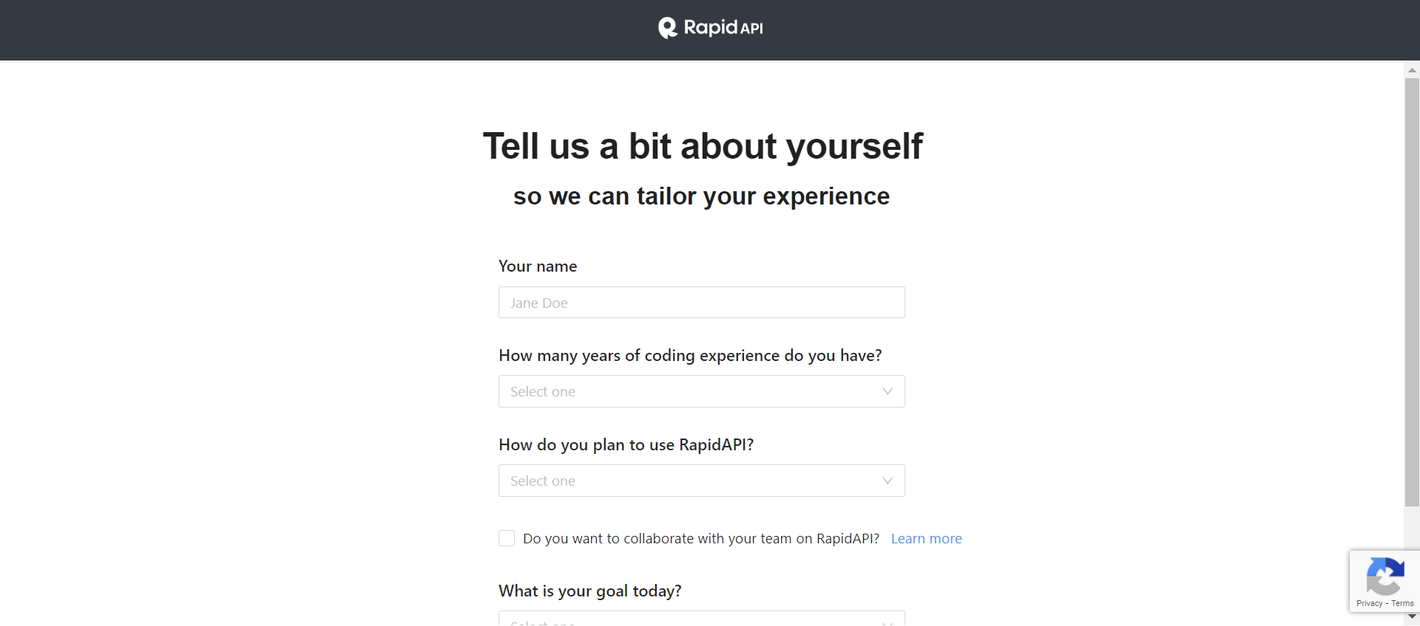



After filling up these details click on Submit.

1. After this Click on API Hub and then search for “Latest Stock Price”.

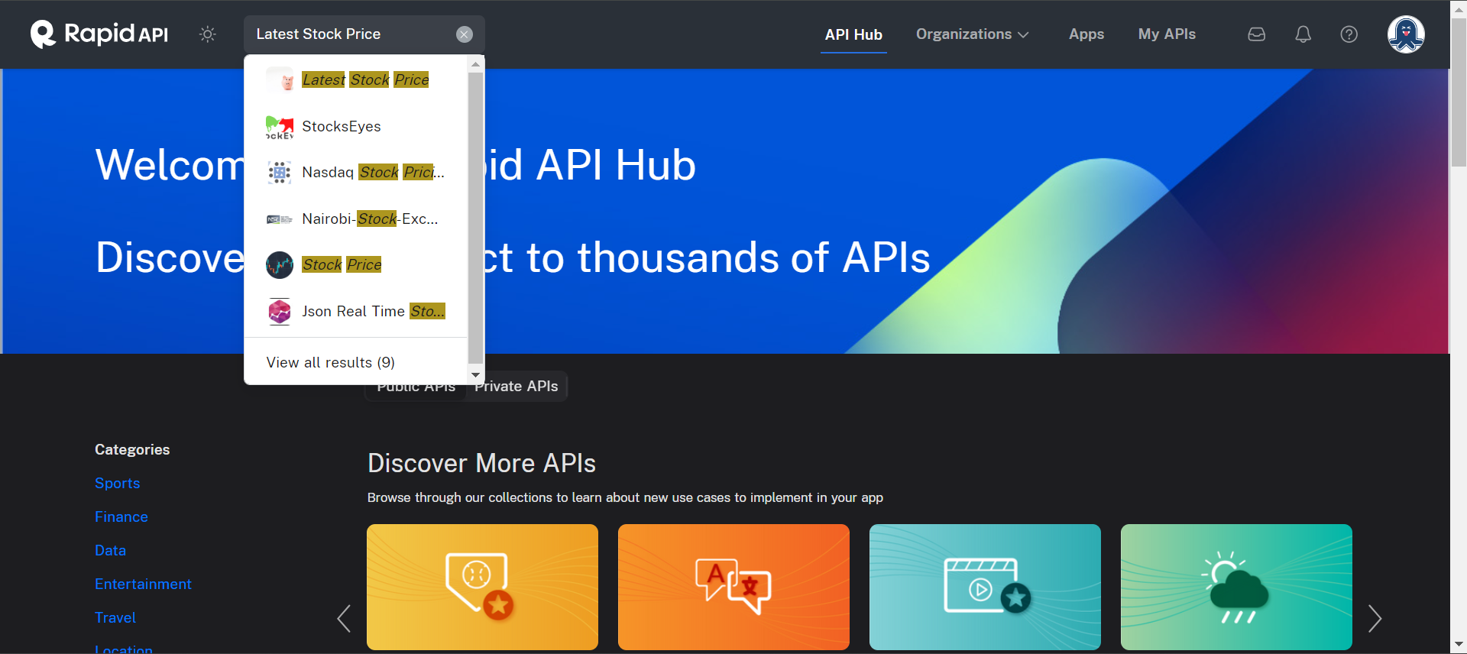

Click on first suggestion.

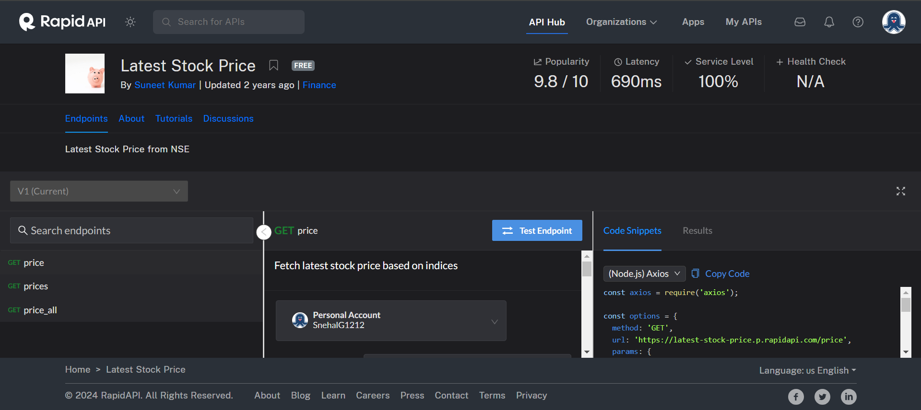

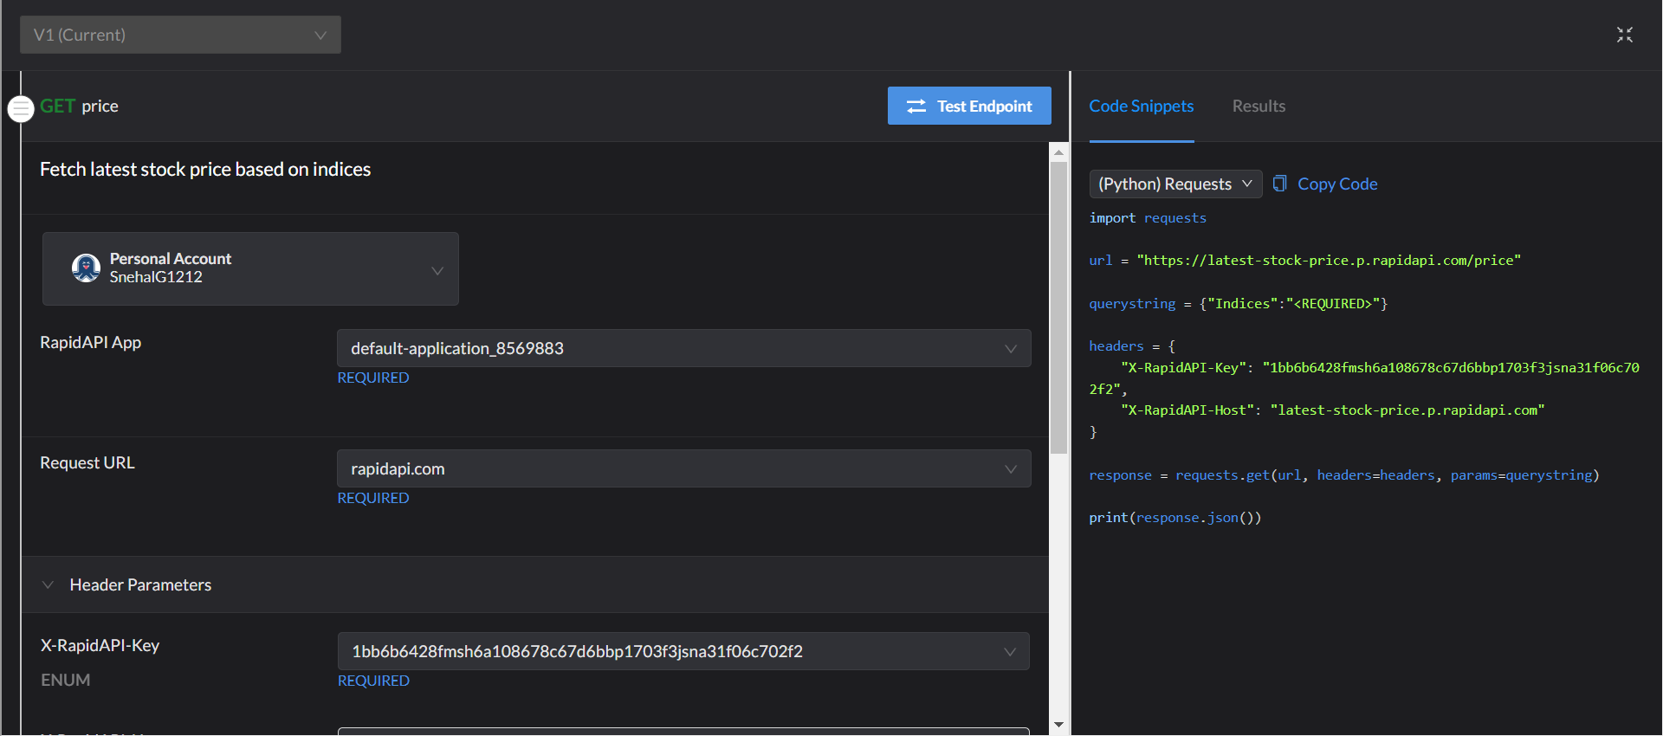

**Here you can choose code for different language and use in your code.**

**Here you can see what API take as input**

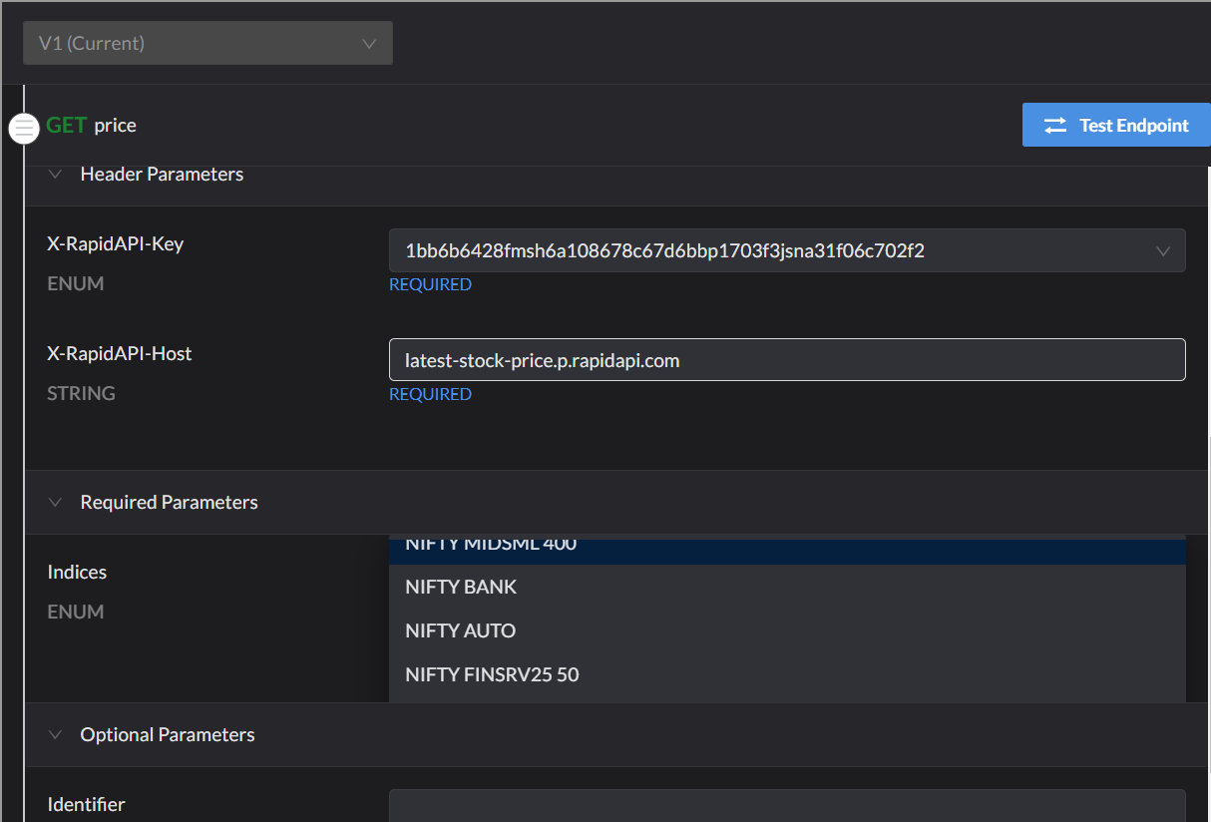

**This API provides prices for the listed stocks only, so ensure you mention only those names.**